PRACTICAL-5 QUEUE
Aim:- Implement various functionalities of queue using linked list.
Theory:-
First a structure of linked list is created, after that front and rear of queue is defined and then a queue is created.
In enqueue we create a new node and assign it data. If front is NULL then both front and rear are updated or else the current rear link is given new node and new node is assigned to rear.
In dequeue if front is NULL then queue is empty and is returned. If not then a temp is assigned front, front is changed to the next of the current front, also if front becomes NULL then rear is also updated to NULL and then the temp is freed.
In printfr if front is NULL queue is empty else front and rear are printed.
Code:-
#include<stdio.h>
struct Node
{
int info;
struct Node *link;
};
struct Queue
{
struct Node *front;
struct Node *rear;
};
struct Queue *createQueue()
{
struct Queue *q=(struct Queue *)malloc(sizeof(struct Queue));
q->front=q->rear=NULL;
return q;
}
void enqueue(struct Queue *q,int item)
{
struct Node *newNode=(struct Node *)malloc(sizeof(struct Node));
newNode->info=item;
newNode->link=NULL;
if (q->front==NULL)
q->front=q->rear=newNode;
else
{
q->rear->link=newNode;
q->rear=newNode;
}
printf("\n%d enqueued to queue\n",item);
}
void dequeue(struct Queue *q)
{
if (q->front==NULL)
{
printf("\nQueue is Empty\n");
return;
}
struct Node *temp=q->front;
q->front=q->front->link;
if (q->front==NULL)
q->rear==NULL;
printf("\n%d dequeued from queue\n",temp->info);
free(temp);
}
void printfr(struct Queue *q)
{
if (q->front==NULL)
{
printf("\nQueue is Empty\n");
}
else
{
printf("\nFront element:- %d",q->front->info);
printf("\nRear element:- %d\n",q->rear->info);
}
}
int main()
{
struct Queue *q=createQueue();
int c,item;
while (1)
{
printf("\nOperations:-\n");
printf("1.Enqueue\n");
printf("2.Dequeue\n");
printf("3.Print front and rear elements\n");
printf("4.Exit\n");
printf("Enter your choice:-");
scanf("%d",&c);
if (c==1)
{
printf("\nEnter element to enter:-");
scanf("%d",&item);
enqueue(q,item);
}
else if (c==2)
dequeue(q);
else if (c==3)
printfr(q);
else if (c==4)
break;
else
printf("\nWrong Choice\n");
}
return 0;
}
Output:-
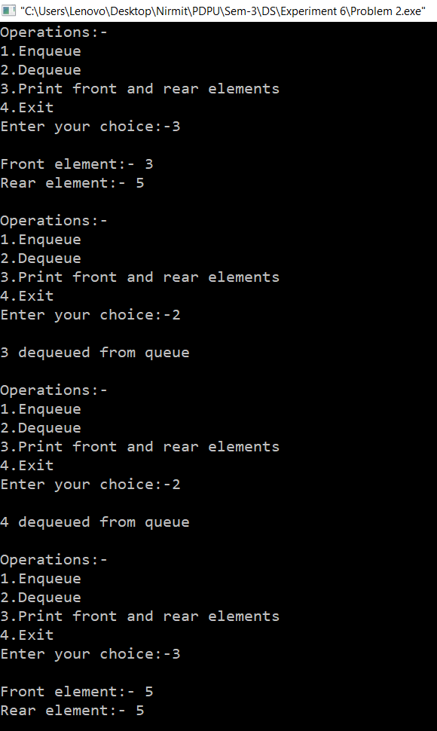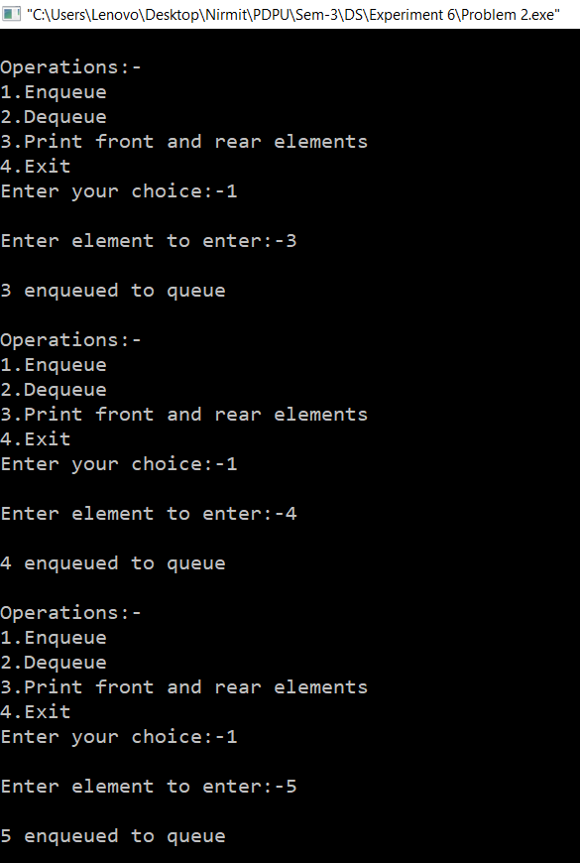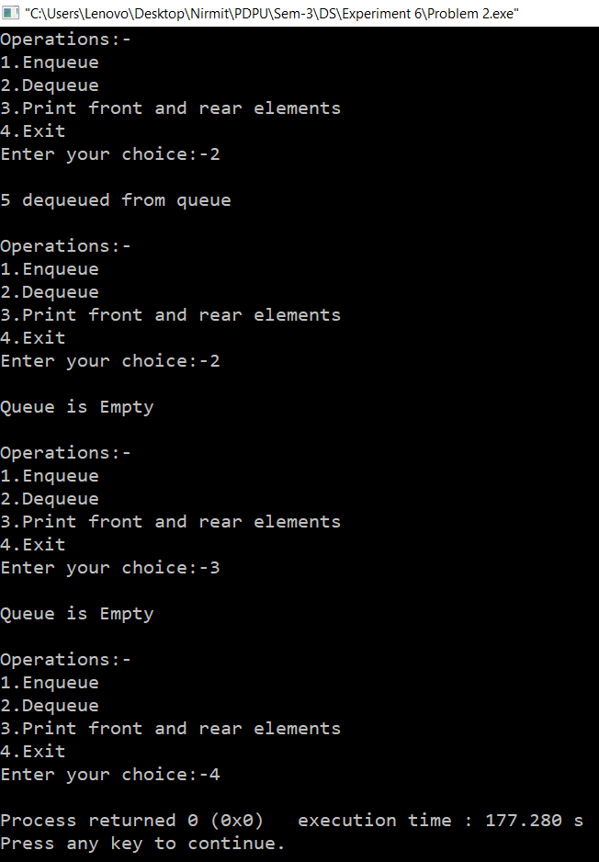
Time Complexity:- O(1) for all the operations while O(n) where n is the number of times a choice is entered other than 4
Space Complexity:- O(n) where n is the number of node in the linked list

